**PYTHON ASSIGNMENT**

1.Consider a list (list = []). You can perform the following commands

* Insert i e: Insert integer at position.
* print: Print the list.
* remove e: Delete the first occurrence of integer .
* append e: Insert integer at the end of the list.
* sort: Sort the list.
* pop: Pop the last element from the list.
* reverse: Reverse the list.

Initialize your list and read in the value followed by lines of commands where each command will be of the types listed above. Iterate through each command in order and perform the corresponding operation on your list.

list =[11,2,3,5,6,7,8]

print("Insert")

list.insert(4,10)

print(list)

print("Append")

list.append(40)

print(list)

print("Pop")

list.pop()

print(list)

print("Print")

print(list)

print("Remove")

list.remove(5)

print(list)

print("Sort")

list.sort()

print(list)

print("Reverse")

list.reverse()

print(list)

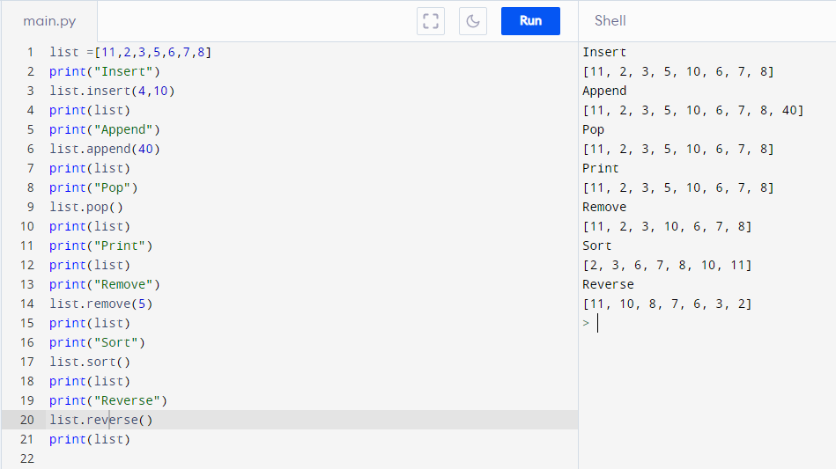

2.Write a Calculator program in Python?

# Functions to add,subtract,multiply and divide two numbers

def add(num1, num2):

return num1 + num2

def subtract(num1, num2):

return num1 - num2

def multiply(num1, num2):

return num1 * num2

def divide(num1, num2):

return num1 / num2

print("Please select operation -\n" \

"1. Add\n" \

"2. Subtract\n" \

"3. Multiply\n" \

"4. Divide\n")

select = int(input("Select operations form 1, 2, 3, 4 :"))

number_1 = int(input("Enter first number: "))

number_2 = int(input("Enter second number: "))

if select == 1:

print(number_1, "+", number_2, "=",

add(number_1, number_2))

elif select == 2:

print(number_1, "-", number_2, "=",

subtract(number_1, number_2))

elif select == 3:

print(number_1, "*", number_2, "=",

multiply(number_1, number_2))

elif select == 4:

print(number_1, "/", number_2, "=",

divide(number_1, number_2))

else:

print("Invalid input")

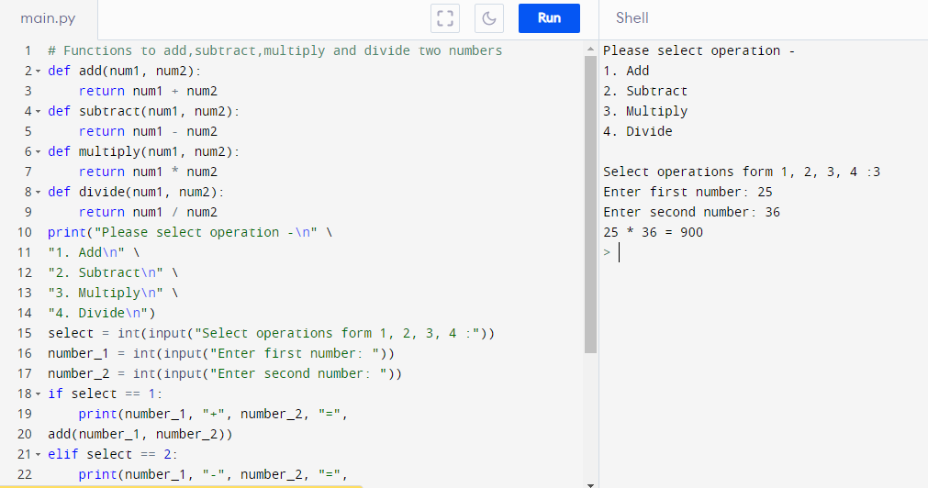

3.Write a program to concatenate, reverse and slice a string?

var1 = "Cloud"

var2 = "Application"

var3 = var1 + var2

print ("String1:",var1)

print ("String2:",var2)

print("--Concatenation--")

print(var3)

def rev(x):

return x[::-1]

print("--Reverse--")

print(rev("hello world"))

def slice(y):

return y[1:3]

print("--Slice--")

print(slice("hello world"))

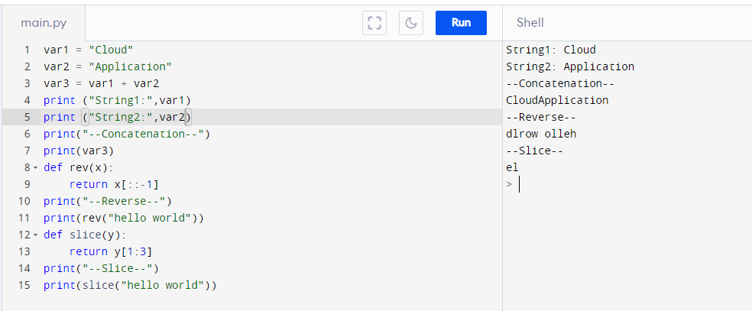

4.Why is Python a popular programming language?

Python is a popular programming language because

* It is easy to learn,
* Ithas an active and supportive community,
* It is flexible
* It offers versatile web development solutions
* It is well suited to data science and analytics
* It is widely used with IOT Technology
* Python is efficient,fast and reliable

5.What are the other Frameworks that can be used with python?

The other Frameworks that can be used with python are

* Django
* CherryPy
* Flask
* TurboGears
* Web2py.
* FastAPI
* Pylons project

6.Full form of WSGI

WSGI - **W**eb **S**erver **G**ateway **I**nterface

It is a simple calling convention for web servers to forward requests to web applications or frameworks written in the Python programming language. The current version of WSGI, version 1.0.